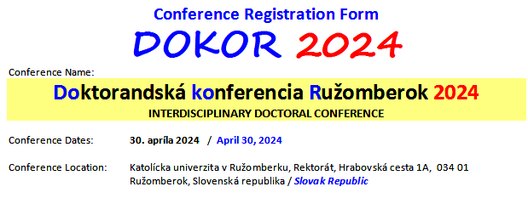
Attendee Information
First Name:

Last Name:

Titles:

University / Company:

Address:

State/Province:

Zip/Postal Code:

Country:

Phone (Please provide full number including country code):

Fax (Please provide full number including country code):

Email:

►►►
Title of the Paper:
①

Title of the Paper:
②

Title of the Paper:
③

►►►
I will attend and present my paper at the conference | □
I will not attend the conference in person | □

